**TON DUC THANG UNIVERSITY**

**FACULTY OF INFORMATION TECHNOLOGY**

**SOFTWARE ENGINEERING**

**FINAL REPORT**

**Name: Lieu Dang Khoa**

**Vi Nguyen Thanh Dat**

**Supervisor: Pham Thai Ky Trung**

**HO CHI MINH CITY, 2022**

# TABLE OF CONTENTS

**TABLE OF CONTENTS** **2**

**1.INTRODUCTION** **4**

**2. Project Management Plan** **5**

2.1. Project Organization 5

2.2. Lifecycle Model Used 5

2.3. Risk Analysis 5

2.4. Hardware and Software Resource Requirements 8

2.5. Deliverables and Schedule 9

2.6. Monitoring, Reporting, and Controlling Mechanisms 9

2.7. Professional Standards 9

2.8. Evidence all the artifacts have been placed under configuration management 9

2.9. Impact of the project on individuals and organizations 9

**3. Requirement Specifications** **10**

3.1. Stakeholders for the system 10

3.2. Use case model 10

3.2.1. Graphical use case model 10

3.2.2. Textual Description for each use case 10

3.3. Functional requirements 10

3.4. Non-functional requirements 10

**4. Architecture** **11**

4.1. Architectural style(s) used 11

4.2. Architectural model 11

4.3. Technology, software, and hardware used 11

4.4. Rationale for your architectural style and model 11

● Saves time: UML can help developers save time by automating some of the design processes 11

● Enhances collaboration: UML allows different software developers to work on the same project by providing a common language 11

● Provides a better understanding of a system: UML can help them understand the system better and identify potential challenges 12

● Unifies design: UML provides a standard way to design software and systems 12

**5. Design** **12**

5.2. Static model – class diagrams 14

5.3. Dynamic model – sequence diagrams 15

5.4. Rationale for your detailed design model 16

5.5. Traceability from requirements to detailed design model 16

**6. Test Plan** **16**

6.1. Requirements/specifications-based system level test cases 16

6.2. Traceability of test cases to use cases 16

6.3. Techniques used for test generation 16

6.4. Assessment of the goodness of your testsuite (Which metrics were used for such 16

**7. Demo** **16**

7.1. Database 16

7.2. Source code 18

7.3. Testing 63

# 1.INTRODUCTION

1.1 Purpose and Scope  
To introduce our product, what it can do, different user cases

1.2. Product Overview (including capabilities, scenarios for using the product, etc.)

Our product helps distribute Supplement Facts products to various companies (agents). Overall, the accountant has the ability to create Good Received when the company imports goods, they shall be able to create Goods Delivery Note to deliver goods to agents, accountants shall be able to view incoming/outgoing stock report, and agents can choose their preferred payment method.

1.3. Structure of the Document

1. Introduction
2. Project Management Plan
3. Requirement Specifications
4. Architecture
5. Design
6. Test Plan
7. Demo
8. References

1.4. Terms, Acronyms, and Abbreviations  
Payment method: methods to purchase goods

Payment status: check if payment has been finished

# 2. Project Management Plan

## 2.1. Project Organization

Our team consists of two members:

* Lieu Dang Khoa
* Vi Nguyen Thanh Dat

## 2.2. Lifecycle Model Used

Waterfall model

## 2.3. Risk Analysis

* **Identify the risks**
  + The risks we face are missing the deadline to submit our finished product
  + We failed to do well in our report due to numerous parts we have to do
  + We risked not designing our product look good enough
  + The database we construct might not be sufficient enough
  + Internet is quite slow in my house and this compromise the whole project
* **Analyze the risks:** We will try to determine the likelihood of each risk and their consequences
  + Missing deadline: 50%, we will get low score on our final, which will be disastrous
  + Failed to perform well in the report: 60%, our score will definitely be affected as report accounts for 30% of total points
  + Bad looking product: 50%, I am not good at designing and so do my friend, our score might be affected
  + Insufficient database: 50%, we don’t have enough data for our product to work with
  + Bad internet: 30%, slow internet connection is a problem but rarely does it affect the overall product
* **Develop a** [**risk management**](https://searchcompliance.techtarget.com/definition/risk-management) **plan:**

| Risks | Impact | Priority | Status |
| --- | --- | --- | --- |
| Missing deadline | Affects overall score | High | Open |
| Failed to perform well in the report | Affects overall score + project schedule | Medium | Open |
| Bad looking product | Affects overall score + cost | Medium | Open |
| Insufficient database | Affects overall product | Medium | Open |
| Bad internet | Affects project schedule + can compromise project | Low | Open |

* **Implement the risk management plan:**

| Risks | Measures to tackle | Priority | Status |
| --- | --- | --- | --- |
| Missing deadline | Rush everyone to finish soon, stay up late at night to do project | High | Open |
| Failed to perform well in the report | Asking for advice from other teams | Medium | Open |
| Bad looking product | Asking for advice from my classmates who are good at designing | Medium | Open |
| Insufficient database | Put more time into research a better database | Medium | Open |
| Bad internet | Go to the internet cafe | Low | Open |

## 2.4. Hardware and Software Resource Requirements

Visual Studio: Visual Studio is an Integrated Development Environment(IDE) developed by Microsoft to develop GUI(Graphical User Interface), console, Web applications, web apps, mobile apps, cloud, and web services.

Windows forms application: is a graphical class library included as part of Microsoft .NET, .NET Framework and is an event-driven application that runs on the desktop computer. A Windows forms application will normally have a collection of controls such as labels, textboxes, list boxes, etc.

ASP.NET MVC is basically a web development framework, which combines the features of MVC (Model-View-Controller) architecture, ideas and techniques from Agile development, and the best parts of the existing ASP.NET platform. It is a complete alternative to traditional ASP.NET Web Forms.2.5. Deliverables and Schedule. It can be used for building websites and web applications on .NET Framework using HTML, CSS, and JavaScript. ASP.NET MVC 5 is a web framework based on Model-View-Controller (MVC) architecture.

## 2.5. Deliverables and Schedule

Due: 12:00 14/12/2022

## 2.6. Monitoring, Reporting, and Controlling Mechanisms

## 2.7. Professional Standards

Skills: knowledge of C#, how to create a windows application, how to create a website, knowledge of Visual Studio overall

Experience: At least 6 months of experience

Behaviors: Finish the product on time, be quick and efficient

## 2.8. Evidence all the artifacts have been placed under configuration management

## 2.9. Impact of the project on individuals and organizations

(Include a description of what impact your project will have on individuals and society)

This product will help a company manage and sell supplemental fact products to other companies.

I can use this product to help sell certain products in a small scale operation, which will increase the local economy

# 3. Requirement Specifications

## 3.1. Stakeholders for the system

We fund the whole project

## 3.2. Use case model

### 3.2.1. Graphical use case model

### 3.2.2. Textual Description for each use case

## 3.3. Functional requirements

1. Accountants should be able to create Goods Received when the company imports goods.
2. Admin can log in to their account
3. The website will always be online
4. Agents shall be able to place an order items and choose their preferred payment methods
5. Accountants shall be able to create Goods Delivery Note to deliver goods to agents
6. Accountants shall be able to view incoming/outgoing stock report,

## 3.4. Non-functional requirements

1. All forms shall be inside the main form
2. There should only be one account of the administrator
3. The website will have a 99% uptime
4. There will be multiple payment options for users to choose from

## 

# **4.** **Architecture**

## 4.1. Architectural style(s) used

Data centered architecture

## 4.2. Architectural model

UML

## 4.3. Technology, software, and hardware used

Visual Studio

Microsoft SQL Server Management Studio

SQL Server

## 4.4. Rationale for your architectural style and model

I use the data centered architecture due to the advantages of this architecture style

* Repository of data is independent of clients
* Client work independent of each other
* It may be simple to add additional clients.
* Modification can be very easy

I use the UML model due to the advantages of it

### Saves time: UML can help developers save time by automating some of the design processes

### Enhances collaboration: UML allows different software developers to work on the same project by providing a common language

### Provides a better understanding of a system: UML can help them understand the system better and identify potential challenges

### Unifies design: UML provides a standard way to design software and systems

# 5. Design

5.1. Database design

Database used:

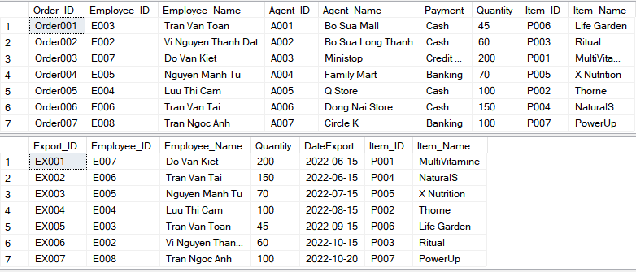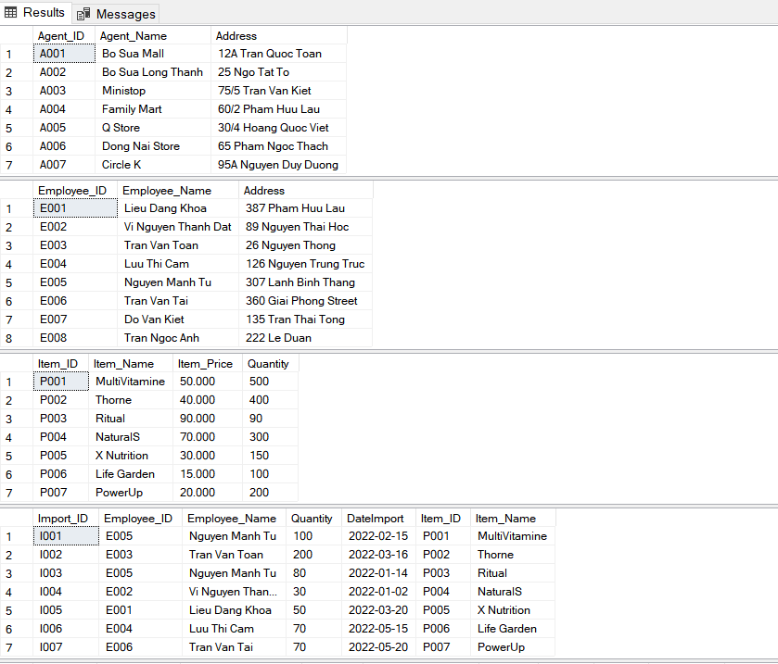

## 

## 

## 5.2. Static model – class diagrams

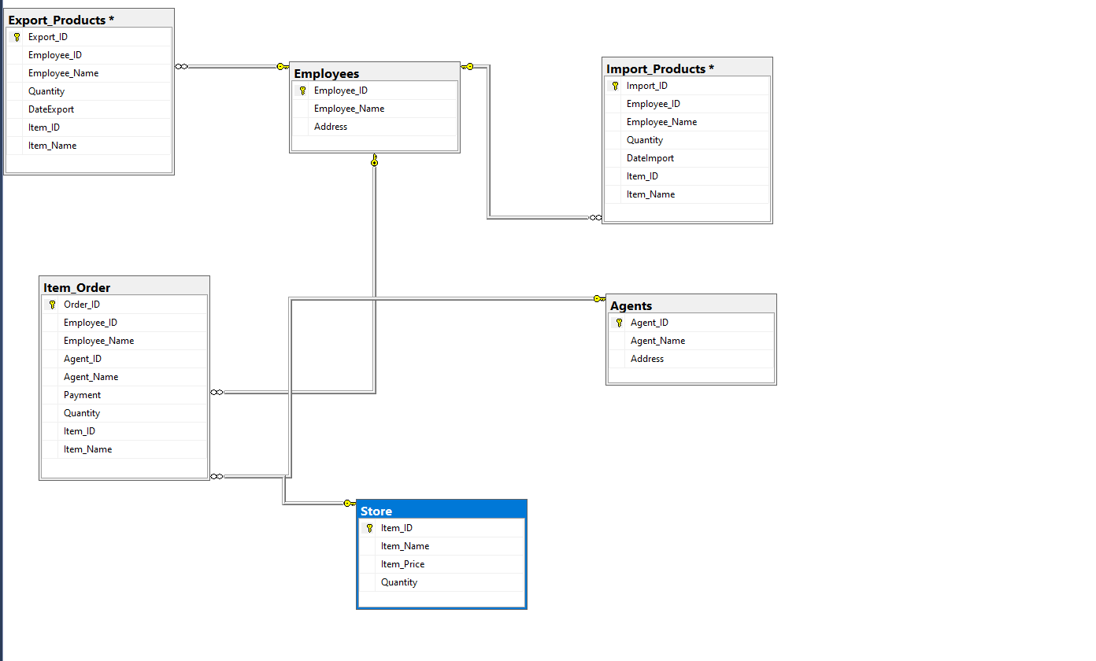

## 5.3. Dynamic model – sequence diagrams

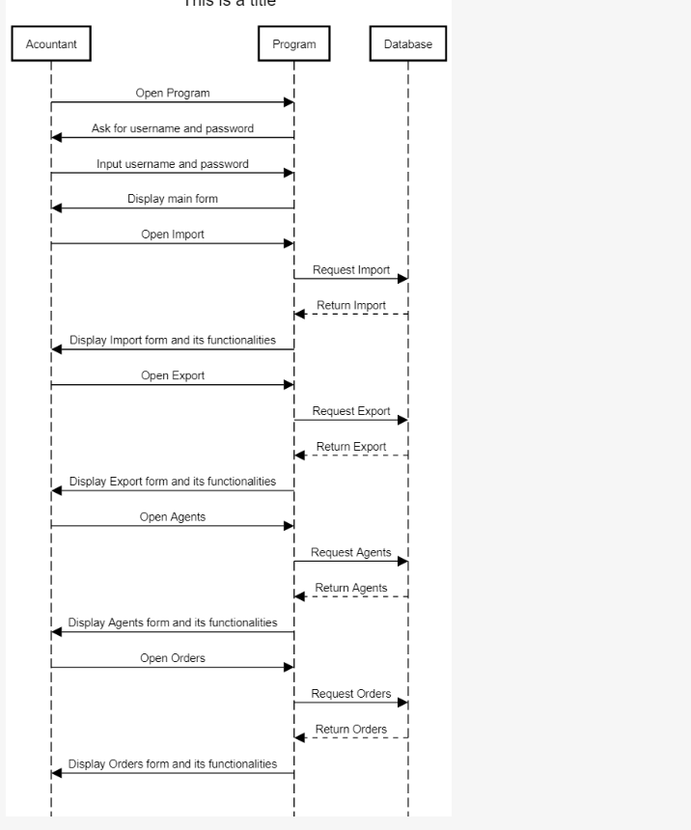

## 5.4. Rationale for your detailed design model

## 5.5. Traceability from requirements to detailed design model

# 6. Test Plan

## 6.1. Requirements/specifications-based system level test cases

Visual Studio application, SQL Server, internet connected computer.

## 6.2. Traceability of test cases to use cases

## 6.3. Techniques used for test generation

## 6.4. Assessment of the goodness of your testsuite (Which metrics were used for such

assessment?)

# 7. Demo

## 7.1. Database

Customer

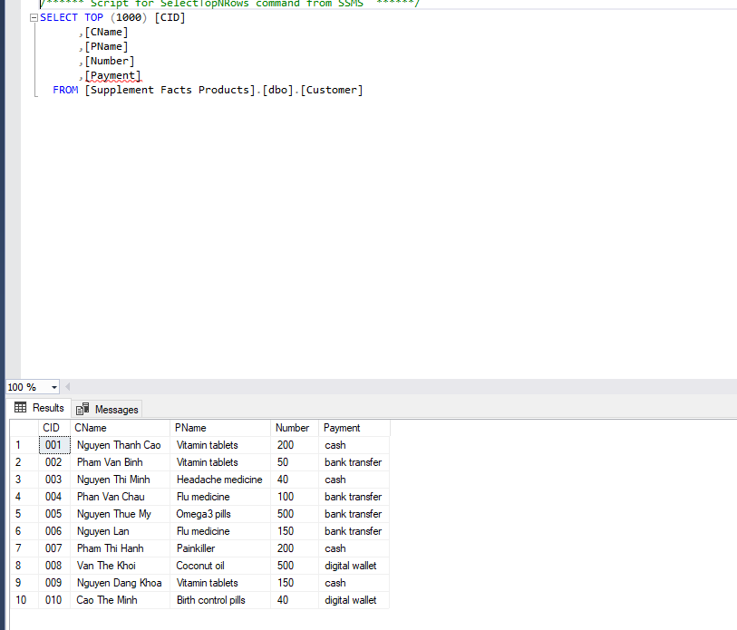

Product_Info

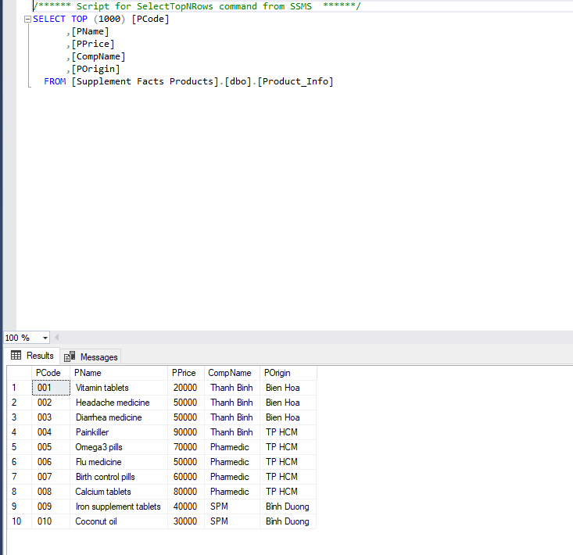

## 7.2. Source code

C# Form:

1. frmMain

using System;

using System.Collections.Generic;

using System.ComponentModel;

using System.Data;

using System.Drawing;

using System.Linq;

using System.Text;

using System.Threading.Tasks;

using System.Windows.Forms;

namespace Final

{

public partial class frmMain : Form

{

public frmMain()

{

InitializeComponent();

}

public void frmLogin()

{

Form frm = new frmLogin();

frm.ShowDialog();

}

/*

public void xemdanhmuc(int intDanhMuc)

{

Form frm = new frmXemDanhMuc();

frm.Text = intDanhMuc.ToString();

frm.ShowDialog();

}*/

private void frmMain_Load(object sender, EventArgs e)

{

frmLogin();

}

private void loginToolStripMenuItem_Click(object sender, EventArgs e)

{

frmLogin();

}

private void exitToolStripMenuItem_Click(object sender, EventArgs e)

{

DialogResult answer;

answer = MessageBox.Show("Are you sure?", "Exit", MessageBoxButtons.YesNo, MessageBoxIcon.Question);

if (answer == DialogResult.Yes) Application.Exit();

}

private void show_panel(Form form)

{

this.pContainer.Controls.Clear();

this.pContainer.Visible = true;

form.Dock = DockStyle.Fill;

form.TopLevel = false;

form.TopMost = true;

form.FormBorderStyle = FormBorderStyle.None;

this.pContainer.Controls.Add(form);

form.Show();

}

private void importToolStripMenuItem_Click(object sender, EventArgs e)

{

Form f = new Import();

show_panel(f);

}

private void exportToolStripMenuItem_Click(object sender, EventArgs e)

{

Form f = new Export();

show_panel(f);

}

private void reportToolStripMenuItem_Click(object sender, EventArgs e)

{

Form f = new Report();

show_panel(f);

}

private void homeToolStripMenuItem_Click(object sender, EventArgs e)

{

this.pContainer.Hide();

}

}

}

1. frmLogin

using System;

using System.Collections.Generic;

using System.ComponentModel;

using System.Data;

using System.Drawing;

using System.Linq;

using System.Text;

using System.Threading.Tasks;

using System.Windows.Forms;

using static System.Windows.Forms.VisualStyles.VisualStyleElement;

namespace Final

{

public partial class frmLogin : Form

{

public frmLogin()

{

InitializeComponent();

}

private void Form1_Load(object sender, EventArgs e)

{

}

private void label1_Click(object sender, EventArgs e)

{

}

private void label2_Click(object sender, EventArgs e)

{

}

private void txtPassword_TextChanged(object sender, EventArgs e)

{

}

private void btnLogin_Click(object sender, EventArgs e)

{

if ((txtUsername.Text == "Admin") && (txtPassword.Text == "123"))

this.Close();

else

{

MessageBox.Show("Wrong password!!!", "Annoucement", MessageBoxButtons.OKCancel, MessageBoxIcon.Warning);

txtUsername.Focus();

}

}

private void btnExit_Click(object sender, EventArgs e)

{

DialogResult answer;

answer = MessageBox.Show("Are you sure ?", "Answer", MessageBoxButtons.YesNo, MessageBoxIcon.Question);

if (answer == DialogResult.Yes)

Application.Exit();

}

}

}

1. Import

using System;

using System.Collections.Generic;

using System.ComponentModel;

using System.Configuration;

using System.Data;

using System.Data.SqlClient;

using System.Drawing;

using System.Linq;

using System.Text;

using System.Threading.Tasks;

using System.Windows.Forms;

namespace Final

{

public partial class Import : Form

{

String strConn = ConfigurationManager.ConnectionStrings["MyConn"].ConnectionString;

public Import()

{

InitializeComponent();

}

private void dataGridView1_CellContentClick(object sender, DataGridViewCellEventArgs e)

{

int index = e.RowIndex;

if (index < 0 || index >= dataGridView1.RowCount)

return;

try

{

DataGridViewRow row = dataGridView1.Rows[index];

String Pcode = Convert.ToString(row.Cells[0].Value);

String PName = Convert.ToString(row.Cells[1].Value);

String Price = Convert.ToString(row.Cells[2].Value);

String CompName = Convert.ToString(row.Cells[3].Value);

String Origin = Convert.ToString(row.Cells[4].Value);

txtPCode.Text = Pcode;

txtPName.Text = PName;

txtPrice.Text = Price;

txtCompName.Text = CompName;

txtOrigin.Text = Origin;

}

catch (Exception ex)

{

throw new Exception("Error:" + ex.Message);

}

}

private void Import_Load(object sender, EventArgs e)

{

SqlConnection conn = new SqlConnection(Program.strConn);

conn.Open();

SqlCommand cmd = new SqlCommand("SELECT * FROM Product_info ", conn);

SqlDataAdapter adapter = new SqlDataAdapter(cmd);

DataTable dt = new DataTable();

adapter.Fill(dt);

if (dt.Rows.Count > 0)

{

dataGridView1.DataSource = dt;

}

else {

MessageBox.Show("No data");

}

adapter.Dispose();

}

private void textBox2_TextChanged(object sender, EventArgs e)

{

}

private void lblCompName_Click(object sender, EventArgs e)

{

}

private void lblPrice_Click(object sender, EventArgs e)

{

}

private void lblPName_Click(object sender, EventArgs e)

{

}

private void lblPCode_Click(object sender, EventArgs e)

{

}

private void txtOrigin_TextChanged(object sender, EventArgs e)

{

}

private void txtCompName_TextChanged(object sender, EventArgs e)

{

}

private void txtPrice_TextChanged(object sender, EventArgs e)

{

}

private void lblOrigin_Click(object sender, EventArgs e)

{

}

private void txtPCode_TextChanged(object sender, EventArgs e)

{

}

private void lblTitle_Click(object sender, EventArgs e)

{

}

private void button1_Click(object sender, EventArgs e)

{

SqlConnection conn = new SqlConnection(Program.strConn);

conn.Open();

String sSQL = "INSERT INTO Product_Info (PCode, PName, PPrice, CompName, POrigin) VALUES (@PCode, @PName, @PPrice, @CompName, @POrigin)";

SqlCommand cmd = new SqlCommand(sSQL, conn);

cmd.Parameters.Add(new SqlParameter("@PCode", txtPCode.Text));

cmd.Parameters.Add(new SqlParameter("@PName", txtPName.Text));

cmd.Parameters.Add(new SqlParameter("@PPrice", txtPrice.Text));

cmd.Parameters.Add(new SqlParameter("@CompName", txtCompName.Text));

cmd.Parameters.Add(new SqlParameter("@POrigin", txtOrigin.Text));

try

{

cmd.ExecuteNonQuery();

}

catch (Exception ex)

{

throw new Exception("Error:" + ex.Message);

}

MessageBox.Show("Save successfully!");

dataGridView1.Refresh();

}

}

}

1. Export

using System;

using System.Collections.Generic;

using System.ComponentModel;

using System.Configuration;

using System.Data;

using System.Data.SqlClient;

using System.Drawing;

using System.Linq;

using System.Text;

using System.Threading.Tasks;

using System.Windows.Forms;

namespace Final

{

public partial class Export : Form

{

String strConn = ConfigurationManager.ConnectionStrings["MyConn"].ConnectionString;

public Export()

{

InitializeComponent();

}

private void dataGridView1_CellContentClick(object sender, DataGridViewCellEventArgs e)

{

int index = e.RowIndex;

if (index < 0 || index >= dataGridView1.RowCount)

return;

try

{

DataGridViewRow row = dataGridView1.Rows[index];

String CID = Convert.ToString(row.Cells[0].Value);

String CName = Convert.ToString(row.Cells[1].Value);

String PName = Convert.ToString(row.Cells[2].Value);

String Number = Convert.ToString(row.Cells[3].Value);

txtCID.Text = CID;

txtCName.Text = CName;

txtPName.Text = PName;

txtNum.Text = Number;

}

catch (Exception ex)

{

throw new Exception("Error:" + ex.Message);

}

}

private void Export_Load(object sender, EventArgs e)

{

SqlConnection conn = new SqlConnection(Program.strConn);

conn.Open();

SqlCommand cmd = new SqlCommand("SELECT * FROM Customer ", conn);

SqlDataAdapter adapter = new SqlDataAdapter(cmd);

DataTable dt = new DataTable();

adapter.Fill(dt);

if (dt.Rows.Count > 0)

{

dataGridView1.DataSource = dt;

}

else

{

MessageBox.Show("No data");

}

adapter.Dispose();

}

private void btnAdd_Click(object sender, EventArgs e)

{

SqlConnection conn = new SqlConnection(Program.strConn);

conn.Open();

String sSQL = "INSERT INTO Customer (CID, CName, PName, Number) VALUES (@CID, @CName, @PName, @Number)";

SqlCommand cmd = new SqlCommand(sSQL, conn);

cmd.Parameters.Add(new SqlParameter("@CID", txtCID.Text));

cmd.Parameters.Add(new SqlParameter("@CName", txtCName.Text));

cmd.Parameters.Add(new SqlParameter("@PName", txtPName.Text));

cmd.Parameters.Add(new SqlParameter("@Number", txtNum.Text));

try

{

cmd.ExecuteNonQuery();

}

catch (Exception ex)

{

throw new Exception("Error:" + ex.Message);

}

MessageBox.Show("Save successfully!");

dataGridView1.Refresh();

}

private void btnEdit_Click(object sender, EventArgs e)

{

SqlConnection conn = new SqlConnection(Program.strConn);

conn.Open();

String sSQL = "UPDATE Customer SET CName = @CName, PName = @PName, Number = @Number WHERE CID = @CID";

SqlCommand cmd = new SqlCommand(sSQL, conn);

cmd.Parameters.Add(new SqlParameter("@CID", txtCID.Text));

cmd.Parameters.Add(new SqlParameter("@CName", txtCName.Text));

cmd.Parameters.Add(new SqlParameter("@PName", txtPName.Text));

cmd.Parameters.Add(new SqlParameter("@Number", txtNum.Text));

try

{

cmd.ExecuteNonQuery();

}

catch (Exception ex)

{

throw new Exception("Error:" + ex.Message);

}

MessageBox.Show("Edit successfully!");

dataGridView1.Refresh();

}

private void btnDelete_Click(object sender, EventArgs e)

{

SqlConnection conn = new SqlConnection(Program.strConn);

conn.Open();

String sSQL = "DELETE FROM Customer WHERE CID = @CID";

SqlCommand cmd = new SqlCommand(sSQL, conn);

cmd.Parameters.Add(new SqlParameter("@CID", txtCID.Text));

try

{

cmd.ExecuteNonQuery();

}

catch (Exception ex)

{

throw new Exception("Error:" + ex.Message);

}

MessageBox.Show("Delete successfully!");

dataGridView1.Refresh();

}

}

}

1. Report

using System;

using System.Collections.Generic;

using System.ComponentModel;

using System.Data;

using System.Data.SqlClient;

using System.Drawing;

using System.Linq;

using System.Text;

using System.Threading.Tasks;

using System.Windows.Forms;

using static System.Windows.Forms.VisualStyles.VisualStyleElement;

namespace Final

{

public partial class Report : Form

{

public Report()

{

InitializeComponent();

}

private void dataGridView1_CellContentClick(object sender, DataGridViewCellEventArgs e)

{

int index = e.RowIndex;

if (index < 0 || index >= dataGridView1.RowCount)

return;

try

{

DataGridViewRow row = dataGridView1.Rows[index];

String CID = Convert.ToString(row.Cells[0].Value);

String CName = Convert.ToString(row.Cells[1].Value);

String PName = Convert.ToString(row.Cells[2].Value);

String Number = Convert.ToString(row.Cells[3].Value);

txtCID.Text = CID;

txtCName.Text = CName;

txtPName.Text = PName;

txtNum.Text = Number;

}

catch (Exception ex)

{

throw new Exception("Error:" + ex.Message);

}

}

private void Report_Load(object sender, EventArgs e)

{

SqlConnection conn = new SqlConnection(Program.strConn);

conn.Open();

SqlCommand cmd = new SqlCommand("SELECT TOP 5 * FROM Customer ORDER BY Number DESC", conn);

SqlDataAdapter adapter = new SqlDataAdapter(cmd);

DataTable dt = new DataTable();

adapter.Fill(dt);

if (dt.Rows.Count > 0)

{

dataGridView1.DataSource = dt;

}

else

{

MessageBox.Show("No data");

}

adapter.Dispose();

}

}

}

In Program.cs we run file “frmMain”

using System;

using System.Collections.Generic;

using System.Linq;

using System.Threading.Tasks;

using System.Windows.Forms;

using System.Configuration;

using System.Data.SqlClient;

namespace Final

{

internal static class Program

{

/// <summary>

/// The main entry point for the application.

/// </summary>

public static string strConn = "";

[STAThread]

static void Main()

{

strConn = ConfigurationManager.ConnectionStrings["MyConn"].ConnectionString;

Application.EnableVisualStyles();

Application.SetCompatibleTextRenderingDefault(false);

Application.Run(new frmMain());

}

}

}

Web MVC:

Views:

Customers:

@model IEnumerable<Website.Models.Customer>

@{

ViewBag.Title = "Index";

}

<h2>Click Order to purchase products:</h2>

<p>

@Html.ActionLink("Order", "Create")

</p>

<table class="table">

<tr>

<th>

@Html.DisplayNameFor(model => model.CName)

</th>

<th>

@Html.DisplayNameFor(model => model.PName)

</th>

<th>

@Html.DisplayNameFor(model => model.Number)

</th>

<th>

@Html.DisplayNameFor(model => model.Payment)

</th>

<th></th>

</tr>

@foreach (var item in Model) {

<tr>

<td>

@Html.DisplayFor(modelItem => item.CName)

</td>

<td>

@Html.DisplayFor(modelItem => item.PName)

</td>

<td>

@Html.DisplayFor(modelItem => item.Number)

</td>

<td>

@Html.DisplayFor(modelItem => item.Payment)

</td>

</tr>

}

</table>

Product_Info:

@model IEnumerable<Website.Models.Product_Info>

@{

ViewBag.Title = "Index";

}

<h2>Index</h2>

<table class="table">

<tr>

<th>

@Html.DisplayNameFor(model => model.PName)

</th>

<th>

@Html.DisplayNameFor(model => model.PPrice)

</th>

<th>

@Html.DisplayNameFor(model => model.CompName)

</th>

<th>

@Html.DisplayNameFor(model => model.POrigin)

</th>

<th></th>

</tr>

@foreach (var item in Model) {

<tr>

<td>

@Html.DisplayFor(modelItem => item.PName)

</td>

<td>

@Html.DisplayFor(modelItem => item.PPrice)

</td>

<td>

@Html.DisplayFor(modelItem => item.CompName)

</td>

<td>

@Html.DisplayFor(modelItem => item.POrigin)

</td>

</tr>

}

</table>

Home:

@{

ViewBag.Title = "Order";

}

<h2>Online Order:</h2>

<div>

<div class="row">

<p>

@Html.ActionLink("Availabel Products:", "Index", "Product_Info")

</p>

<p>

@Html.ActionLink("Order now:", "Index", "Customers")

</p>

</div>

</div>

Controllers:  
 CustomerController.cs:

using System;

using System.Collections.Generic;

using System.Data;

using System.Data.Entity;

using System.Linq;

using System.Net;

using System.Web;

using System.Web.Mvc;

using Website.Models;

namespace Website.Controllers

{

public class CustomersController : Controller

{

private Conn db = new Conn();

// GET: Customers

public ActionResult Index()

{

return View(db.Customers.ToList());

}

// GET: Customers/Details/5

public ActionResult Details(string id)

{

if (id == null)

{

return new HttpStatusCodeResult(HttpStatusCode.BadRequest);

}

Customer customer = db.Customers.Find(id);

if (customer == null)

{

return HttpNotFound();

}

return View(customer);

}

// GET: Customers/Create

public ActionResult Create()

{

return View();

}

// POST: Customers/Create

// To protect from overposting attacks, enable the specific properties you want to bind to, for

// more details see https://go.microsoft.com/fwlink/?LinkId=317598.

[HttpPost]

[ValidateAntiForgeryToken]

public ActionResult Create([Bind(Include = "CID,CName,PName,Number,Payment")] Customer customer)

{

if (ModelState.IsValid)

{

db.Customers.Add(customer);

db.SaveChanges();

return RedirectToAction("Index");

}

return View(customer);

}

// GET: Customers/Edit/5

public ActionResult Edit(string id)

{

if (id == null)

{

return new HttpStatusCodeResult(HttpStatusCode.BadRequest);

}

Customer customer = db.Customers.Find(id);

if (customer == null)

{

return HttpNotFound();

}

return View(customer);

}

// POST: Customers/Edit/5

// To protect from overposting attacks, enable the specific properties you want to bind to, for

// more details see https://go.microsoft.com/fwlink/?LinkId=317598.

[HttpPost]

[ValidateAntiForgeryToken]

public ActionResult Edit([Bind(Include = "CID,CName,PName,Number,Payment")] Customer customer)

{

if (ModelState.IsValid)

{

db.Entry(customer).State = EntityState.Modified;

db.SaveChanges();

return RedirectToAction("Index");

}

return View(customer);

}

// GET: Customers/Delete/5

public ActionResult Delete(string id)

{

if (id == null)

{

return new HttpStatusCodeResult(HttpStatusCode.BadRequest);

}

Customer customer = db.Customers.Find(id);

if (customer == null)

{

return HttpNotFound();

}

return View(customer);

}

// POST: Customers/Delete/5

[HttpPost, ActionName("Delete")]

[ValidateAntiForgeryToken]

public ActionResult DeleteConfirmed(string id)

{

Customer customer = db.Customers.Find(id);

db.Customers.Remove(customer);

db.SaveChanges();

return RedirectToAction("Index");

}

protected override void Dispose(bool disposing)

{

if (disposing)

{

db.Dispose();

}

base.Dispose(disposing);

}

}

}

Product_InfoController.cs:

using System;

using System.Collections.Generic;

using System.Data;

using System.Data.Entity;

using System.Linq;

using System.Net;

using System.Web;

using System.Web.Mvc;

using Website.Models;

namespace Website.Controllers

{

public class Product_InfoController : Controller

{

private Conn db = new Conn();

// GET: Product_Info

public ActionResult Index()

{

return View(db.Product_Info.ToList());

}

// GET: Product_Info/Details/5

public ActionResult Details(string id)

{

if (id == null)

{

return new HttpStatusCodeResult(HttpStatusCode.BadRequest);

}

Product_Info product_Info = db.Product_Info.Find(id);

if (product_Info == null)

{

return HttpNotFound();

}

return View(product_Info);

}

// GET: Product_Info/Create

public ActionResult Create()

{

return View();

}

// POST: Product_Info/Create

// To protect from overposting attacks, enable the specific properties you want to bind to, for

// more details see https://go.microsoft.com/fwlink/?LinkId=317598.

[HttpPost]

[ValidateAntiForgeryToken]

public ActionResult Create([Bind(Include = "PCode,PName,PPrice,CompName,POrigin")] Product_Info product_Info)

{

if (ModelState.IsValid)

{

db.Product_Info.Add(product_Info);

db.SaveChanges();

return RedirectToAction("Index");

}

return View(product_Info);

}

// GET: Product_Info/Edit/5

public ActionResult Edit(string id)

{

if (id == null)

{

return new HttpStatusCodeResult(HttpStatusCode.BadRequest);

}

Product_Info product_Info = db.Product_Info.Find(id);

if (product_Info == null)

{

return HttpNotFound();

}

return View(product_Info);

}

// POST: Product_Info/Edit/5

// To protect from overposting attacks, enable the specific properties you want to bind to, for

// more details see https://go.microsoft.com/fwlink/?LinkId=317598.

[HttpPost]

[ValidateAntiForgeryToken]

public ActionResult Edit([Bind(Include = "PCode,PName,PPrice,CompName,POrigin")] Product_Info product_Info)

{

if (ModelState.IsValid)

{

db.Entry(product_Info).State = EntityState.Modified;

db.SaveChanges();

return RedirectToAction("Index");

}

return View(product_Info);

}

// GET: Product_Info/Delete/5

public ActionResult Delete(string id)

{

if (id == null)

{

return new HttpStatusCodeResult(HttpStatusCode.BadRequest);

}

Product_Info product_Info = db.Product_Info.Find(id);

if (product_Info == null)

{

return HttpNotFound();

}

return View(product_Info);

}

// POST: Product_Info/Delete/5

[HttpPost, ActionName("Delete")]

[ValidateAntiForgeryToken]

public ActionResult DeleteConfirmed(string id)

{

Product_Info product_Info = db.Product_Info.Find(id);

db.Product_Info.Remove(product_Info);

db.SaveChanges();

return RedirectToAction("Index");

}

protected override void Dispose(bool disposing)

{

if (disposing)

{

db.Dispose();

}

base.Dispose(disposing);

}

}

}

HomeController.cs:

using System;

using System.Collections.Generic;

using System.Linq;

using System.Web;

using System.Web.Mvc;

namespace Website.Controllers

{

public class HomeController : Controller

{

public ActionResult Index()

{

return View();

}

public ActionResult About()

{

ViewBag.Message = "Your application description page.";

return View();

}

public ActionResult Contact()

{

ViewBag.Message = "Your contact page.";

return View();

}

public ActionResult Order()

{

ViewBag.Message = "Your contact page.";

return View();

}

}

}

Model: ProductDB

## 7.3. Testing

<https://youtu.be/fBAYfDXwBqE>